HELP SAVE LIVES!
WALK WITH US

“FIGHT SUICIDE” Walk-a-Thon
JUNE 13, 2020, Saturday
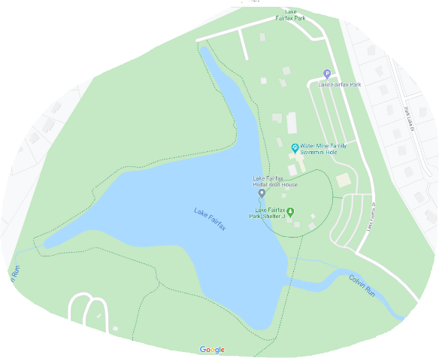
Lake Fairfax Park
1400 Lake Fairfax Dr, Reston, VA 20190

Shelter J
3-Mile Round Walk

8:30 FREE Registration at Shelter J
9:00 Welcome and Opening Remarks
Walk to Follow

- Save time by FREE pre-registering at www.fccgw.org
- For support and volunteer at www.fccgw.org
- T-shirts will be available with online pre-registration and at the event. Limited quantities available.
- There will be refreshments and information booths all morning.
The Family Counseling Center of Greater Washington (FCCGW) www.FCCGW.org
1952 Gallows Road, Suite 210, Vienna, VA 22182
T. 703-761-2225, 2226 F. 703-761-2227 Email: counseling@fccgw.org

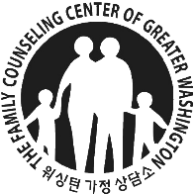

Know WARNING SIGNS of suicide
The signs may appear in conversations, through their actions, or in social media posts. If you observe one or more of these warning signs, especially if the behavior is new, has increased, or seems related to a painful event, loss, or change, step in or speak up.
• Personality change
• Withdrawal
• Changes in sleep
• Reckless behavior
• Substance abuse
• Physical pain
• Giving away belongings
• Sudden mood changes
• Neglect of personal appearance
• Loss of interest

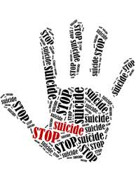

The Family Counseling Center of Greater Washington (FCCGW) www.FCCGW.org
1952 Gallows Road, Suite 210, Vienna, VA 22182
T. 703-761-2225, 2226 F. 703-761-2227 Email: counseling@fccgw.org

